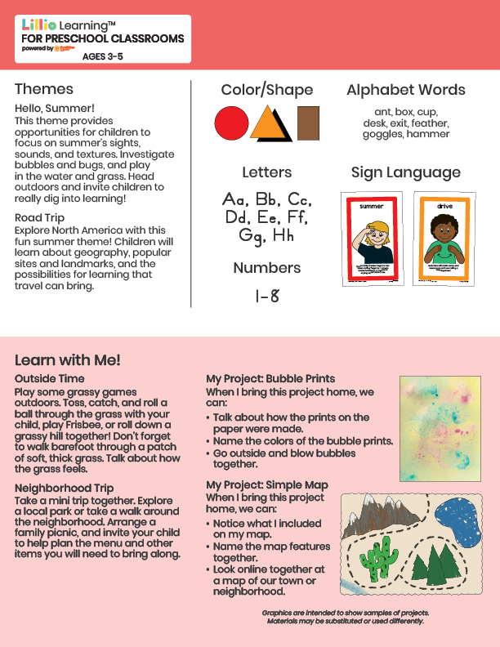­

Add Your Name/Logo Here

June 2025

Newsletter

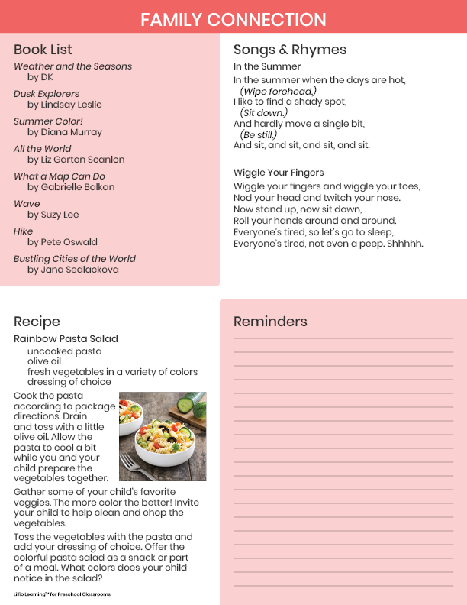

Add Notes